DRAFT
Plymouth HRA Strategic Plan

City of Plymouth Housing and Redevelopment Authority | 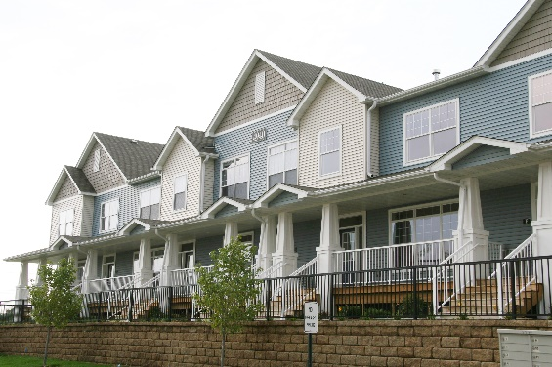  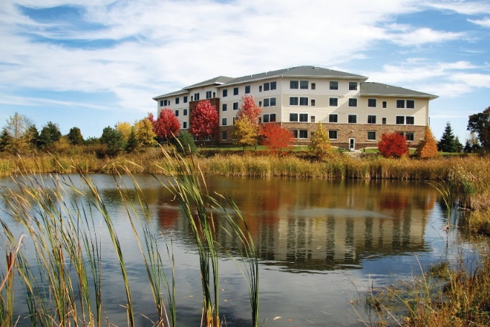
Adopted: _____________ | 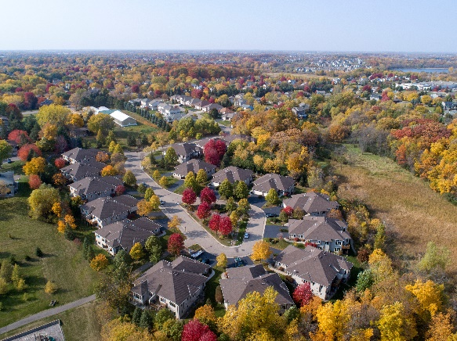

Table of Contents

Background…………………………………………………………………Page 3-4
The Process…………………………………………………………………Page 5
HRA Housing Priorities and Actions to Consider ………… ………Pages 6-13
Implementation……………………………………………………………Pages 14-15
Plymouth HRA
Mission & Values

Mission. The Plymouth Housing and Redevelopment Authority promotes and contributes to the economic health of the community through the creation and maintenance of affordable, workforce and life-cycle housing, and active participation in the City’s development and redevelopment processes.

Values. The Plymouth Housing and Redevelopment Authority is a facilitator and significant contributor to creating an economically healthy and diverse community:

- Which is supportive of quality affordable and workforce housing for all incomes and family sizes.
- That promotes a variety of affordable, workforce and life-cycle housing choices dispersed throughout the City to meet the needs of a diverse population, local employment needs, household stability and educational success of children.
- Where the existing housing stock is well maintained.
- Where some older commercial buildings and areas of the community are redeveloped in a timely fashion.
- Which acquires additional resources to proactively address affordable housing shortages and redevelopment needs.
- Where the HRA works in partnership with citizens, businesses, the City Council and other City departments, and other organizations.
- Where the social services necessary to support housing and jobs in the community are available and coordinated.
- Where the HRA is committed to promoting Fair Housing and equal access and opportunity in housing.

Background
The Plymouth Housing and Redevelopment Authority (HRA) has been an independent governmental entity since its initial creation by the City Council in 1975. The HRA is governed by a board of commissioners appointed by the City Council. Commissioners serve five-year staggered terms.
HRA members who participated in development of the HRA Strategic Plan include the following:
- Michelle Soderberg, HRA Chair
2040 City Comprehensive Plan
Value Statements

- Maintain and enhance housing quality and diversity. Plymouth values housing that is attractive, well-constructed and maintained to ensure quality of life for all residents. Plymouth also values diverse housing opportunities in neighborhoods throughout the community, including affordable housing, renter and owner-occupied housing, senior housing and lifecycle housing.

- Meet the needs of all age groups within the City, with a particular focus on young people and the aging population. Plymouth recognizes that the nation is aging. And the City is no exception. Plymouth will pay increased attention to the special needs of its aging population in all aspects of community life – housing, all forms of transportation, services and facilities and especially, sense of community.
- Jeff Kulaszewicz
- Lucas Larson
- Aqueelah Whitfield
- Bob Huddleston
- Jim Davis, City Council Representative to the HRA
The HRA’s charge is to oversee and guide in the implementation of Plymouth’s housing programs and collaborate on redevelopment efforts of the City. They manage federal, state, and local grants for housing programs and administer eight active Tax Increment Financing (TIF) Districts. Funding for the HRA programs comes from the Federal Department of Housing and Urban Development (HUD) and Community Development Block Grants (CDBG), and an annual HRA levy. These funding sources support staff, existing program implementation, and the maintenance, management and administration of two HRA owned senior housing properties; Plymouth Towne Square and Vicksburg Crossing.

Existing programs supported by the HRA include the following:
- CDBG Programs:
2040 City Comprehensive Plan
Housing Goals

- Promote the development and preservation of a supply of quality housing that is affordable at all income levels and at all stages of the life cycle.

- Encourage and ensure that all housing and neighborhoods in Plymouth are well maintained.

- Promote development patterns that link housing with services and employment centers by all forms of transportation, particularly public transit and non-motorized forms of transportation.

- Metropolitan Council identifies that Plymouth’s share of the regions need of affordable housing between 2021-2030 is 674 additional units, of which 87% should be affordable to those with incomes at or below 50% of the area median income.

- Plymouth has guided vacant land in the City to accommodate the construction of 736 affordable units.
  - First Time Homebuyer Program
  - Owner Occupied Home Rehabilitation Program
  - Owner Occupied Emergency Repair Program
  - Social Services
  - Rental Rehab Program
- Housing Choice Voucher Program
- Senior Rental Housing
- Architectural Design Program
- Home Energy Squad Plus
- Multi-Family Fire Suppression Program
- Housing Improvement Area Program
- Community Land Trust Program
- Scattered Site Rental Program
- Private Utility Repair Program



The Process

The HRA completed a process over the course of several months to develop a strategic plan that will solidify key HRA goals, priorities, actions and funding needs for the City and to gain consensus on the role of the HRA in supporting the housing and redevelopment needs of the City. The outreach and engagement process was conducted in a virtual format due to the limitation brought on by the Covid-19 pandemic.
Stakeholder Comments
- As the gap between housing costs and incomes increases there is a higher risk of families and children becoming homeless – ODC
- There is a need for larger (3 and 4 bedroom) affordable housing units for families – ODC
- Support higher densities to provide more opportunities for the private sector to develop new housing and commercial options desired by residents – Developer Roundtable
- Support zoning land for higher densities and being more flexible in local land use, building requirements and processing time is important – Developer Roundtable
- The top three Flashvote responses on what local residents (986) would like to see more of included:
- 55% renovate older buildings
- 45% mixed use housing
- 42% first time homebuyer assistance

The strategic planning process identified the priorities and actions outlined in this plan based upon review and evaluation of the following:
- 2040 Comprehensive Plan
- Comprehensive Rental Housing Market Study dated April 4, 2018
- Plymouth Hennepin County Consortium Consolidated Plan FY2020-2024
- 2013 Plymouth HRA Strategic Plan
- Strengths, Weaknesses, Threats and Opportunities Summary completed by the HRA and dated October 14, 2020
- Stakeholder input through Zoom and phone interviews and online surveys by residents, the City Council and HRA members.
- Stakeholder interviews including representatives from Interfaith Outreach Community Partners, Outreach Development Corporation (ODC) Board of Directors, RE/MAX, former Wells Fargo Community Lender, Summit Mortgage, Plymouth Covenant Church, Mount Olivet Church of Plymouth, Messiah Church and Wayzata Schools (Community Engagement and Partnership Coordinator, Academic Interventionist, Director of Community Education and Principal on Special Assignment.)
- A developer work session of the HRA and City Council on July 23, 2020 which included representatives from Doran Companies, Ryan Companies and CommonBond
- HRA and City Council online survey of priorities and needs completed by 80 percent of the members
- City of Plymouth flash vote completed by 1,042 Plymouth residents – 1,197 total participants which included 1,139 responding (62%) of the 1852 initially invited and 58 new participants

HRA Priorities

- Preservation of Existing Housing and Tenant Protections

The most affordable housing is within the existing older properties, referred to as Naturally Occurring Affordable Housing (NOAH).

HRA Priority: Support preservation of existing rental housing and protect vulnerable and low-income households.
The Facts: Need for Preservation and Protection of Tenants
- The City’s existing rental housing stock is aging - 47% of the rental housing in the City was built in the 1970s and 1980s.

- 28% of the City’s residents live in rental housing.

- 43% (3,736) of renter households, are paying more than 30% of their income on housing cost, increasing the risk of residents choosing between paying rent, eating, covering healthcare costs and other critical life and safety needs.

- Median rent increased 18% from 2010 to 2018; at the same time there was less available housing with a 29% reduction in the vacancy rate from 5.5% to 3.9%.

- From 2010 to 2018, 10 apartment properties sold representing 3,456 units in the City.

- In-demand jobs in the Twin Cities do not pay enough to afford the median rent or mortgage in Plymouth. These include critical workers to support business vitality and resident services such as cashiers, retail workers, personal care aides, nursing assistants, janitors and customer service representatives.

Sources: Plymouth Maxfield Study, Plymouth 2040 Comprehensive Plan, MHP’s Plymouth Rental Snapshot, MHP’s Market Watch; Hennepin County Report

- Tenant Protection Ordinance:

  - Goal: Protect vulnerable and lower income residents from being displaced due to rent increases without time to find alternate housing and provided an opportunity for residents at risk of losing housing to be connected to housing and social assistance.

  - Action: Consider adoption of a tenant protection ordinance that would outline requirements to protect tenants from being displaced when properties change ownership. Best practices include providing tenants a three (or longer) months period where there is a pause on rent increases, tenant re-screening, and non-renewal of leases without cause. An ordinance can spell out options where a new owner chooses or does not comply with the pause that can include a requirement to pay relocation benefits to tenants.

- Local 4d Affordable Housing Incentive

  - Goal: Protect vulnerable and lower income residents by preserving existing unsubsidized affordable rental units in exchange for a lower tax applied to those units. In many cases, existing properties are already providing rents at or below 60% of the area median income. However, those units are most at risk of rent escalation as vacancy rates lower and the availability of lower rental housing is reduced.

  - Action: Evaluate adoption of a local 4d Affordable Housing Incentive that would provide qualifying existing rental property owners a rate reduction in property taxes from the current 1.25% to .75% per MN Statute 273.128 for qualifying rent restricted units. Per the state statute a minimum of 20% of the total units would need to have rent and income restrictions for those at or below 60% of the current area median income to be eligible for the reduced tax rate on those units. To trigger the program, the HRA, as the local unit of government, would provide nominal financial assistance to the property owner who then enters into a development agreement which outlines the rent restrictions and terms. The total amount of the reduction would be evidenced by a document recorded against the property.

- NOAH Rehabilitation and Maintenance Program

  - Goal: Encourage property improvements that increase property values while protecting vulnerable and lower income residents by ensuring that a portion of a property’s rents remains affordable when these properties are improved to protect the health, safety and livability of the City’s older rental properties.

  - Action: Consider expanding funding and criteria for restricting rents focused on providing assistance to existing older rental properties that are in need of renovation such as exterior improvements, energy efficiency upgrades, fire suppression systems and other health, safety, crime reduction and livability improvements. The assistance would be provided to help finance improvements in exchange for ensuring that a portion of the rents are kept affordable at or below 60% of the current area median incomes. The financial assistance could be structured as a loan or grant. A development agreement with the property owner that would include a covenant on the deed of the property, would be required to ensure the owners comply with the income requirements.

HRA Housing Priorities (continued)

- Increase Housing Affordability to Diversify Housing Options and Opportunity in the City
The Facts: Importance of Diversifying Housing Options
- Only 1% (18 units) of the new housing constructed in the City between 2015-18 can be considered “affordable” to a household earning less than 60 percent of the area median income which is $60,000 for a family of four.

- Senior Housing Need: The population growth from 2017 to 2022 for those age 75 to 84 is projected to have the greatest percentage growth at 32%. Incomes of current older residents are lower than the median incomes in the City. In 2017, 10% of those senior households had incomes below $15,000 per year. Many City senior households wish to remain within their existing homes or may wish to move out but cannot afford other alternatives.

- Entry Level Housing Need: The population of 18 to 34-year old’s is expected to increase slightly 445 people (+1.4%) between 2017 and 2022. These are the residents that tend to rent and may be looking to put down roots in the community by purchasing their first home.

- Through October of 2020, 1,300 homes were sold with a median sales price of $392,000: up 3% from the previous year; an unaffordable option for many first-time buyers.

Sources: Plymouth Maxfield Study, MHP’s Plymouth Rental Snapshot, Realtor Association Sale Data
To achieve the mission of the HRA, it is important to provide opportunities to diversify the housing options and support new affordable housing including seniors, low-income families and the younger generation.

HRA Priority: Support more development of affordable housing and increase housing options and opportunities in the
City.

- Mixed Income Housing Policy

  - Goal: Ensure high quality housing in the City is accessible to households with a variety of incomes, ages, and sizes and to increase the supply of new affordable senior and rental housing options.

  - Action: Consider and evaluate options for adoption of a mixed income housing policy. Mixed income housing policy (referred to as inclusionary housing policy) can tie financial or land use assistance for new housing to include a certain percentage of the total units as affordable. Some policies allow a financial contribution rather than providing units within the proposed development. Evaluations would consider the parameters that trigger the policy and outline the percentage of affordable units and/or cash contribution formula. Mixed income policy options include various triggers (city assistance, land use change, number of units, etc.) that is outlined when created and adopted.

- Affordable First-Time Buyers Options
  - Goal: Increase the opportunity of affordable first-time homebuyers and to revitalize existing older single-family neighborhoods.
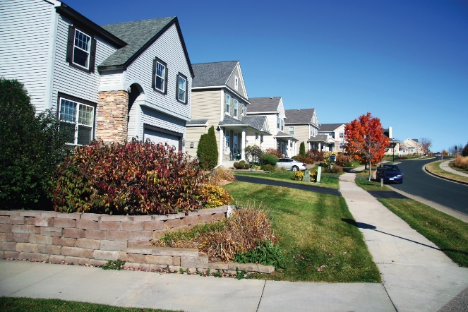
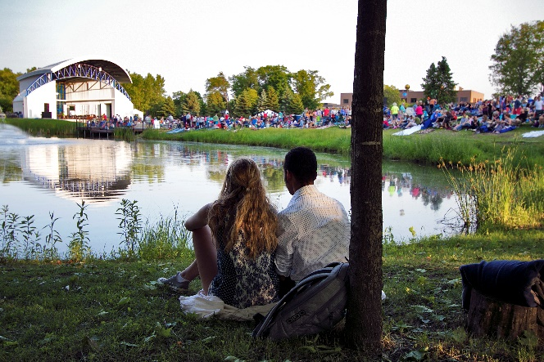
  - Action: Evaluate expanding program criteria and policies to support the purchase and/or development of affordable, first time home buyer options. Programs and policies to be evaluated will include the enhancement of existing support for Community Land Trusts, down payment assistance and lower mortgage options. In addition, innovative program options to consider can include partnering with non-profit housing providers by providing gap funding to facilitate the connection with first time buyers to purchase existing homes from senior households who wish to sell their home.

- Resident and Policy Leader Support of Affordable Housing
  - Goal: Increase understanding of the economic and social benefits of a diverse and inclusive community that provides housing affordability options to all residents and workers in the City.
  - Action: Partner to provide forums to engage and educate residents, property owners, landlords, property managers, and government leadership on market realities, educational attainment impacts, worker recruitment and retention and health benefits of a diverse and inclusive community with a full range of housing options.

HRA Housing Priorities (continued)

- Proactively Support Redevelopment Efforts of the City

As the City of Plymouth becomes fully developed, reuse and redevelopment of property will become more important to ensure that property values remain stable and to increase options and opportunities for residents and businesses. Reuse of land that includes a mix of uses and more compact development provides options for active living, such as walking or biking, within proximity to retail, services and other amenities.

HRA Priority: Assist in prioritizing redevelopment opportunities and future land uses to support a mix of land uses and options for compact living.

- Identify and Prioritize Areas for Redevelopment

  - Goal: Provide clarity, consistency, and flexibility to attract private investment in redevelopment areas of the City and ensure that market demand and community vision align.

  - Actions: In cooperation with the City Council and other City departments, the HRA will assist with the following redevelopment efforts, where appropriate.

    - Provide input on and identify key areas of the City that need redeveloping.
    - Identify acceptable mixes of future land uses such as affordable housing, ownership/rental mix and mix of uses for redevelopment areas.
    - Identify best practices and policies for fast-track approvals and flexibility when the project meets certain requirements.

- Assist with Assembly of Land for Redevelopment

  - Goal: Increase partnerships and opportunities in the redevelopment of land by leveraging property control to support community goals, facilitate and promote private investment and increase availability of affordable housing.

  - Action: Provide assistance in identifying site acquisition tools and financing options to support assemblage of key (re)development sites under multiple ownership.

- Educate the Community and Policy Leaders on the Benefits of Investing in Redevelopment

  - Goal: Facilitate and support agreement on redevelopment priorities through education, collaboration and increased engagement of residents to support a healthy and vibrant community.

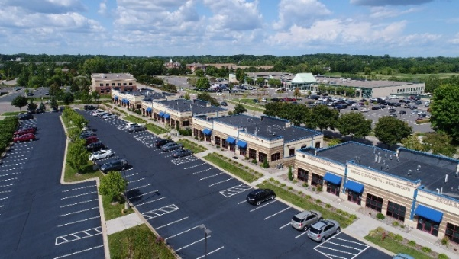
  - Actions: Partner to promote and facilitate forums and processes for ongoing education of government leadership on current market realities, redevelopment goals, and plans including the following:
    - Educate newly elected and appointed policy leaders on HRA mission, values, priorities and goals.
    - Conduct site visits and tours of successful regional redevelopment projects.
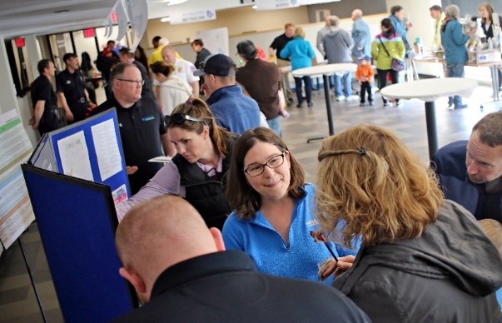
    - Conduct stakeholder engagement sessions/neighborhood meetings; engage underrepresented populations.
    - Clearly document stakeholder support for the redevelopment plan or plans.

HRA Housing Priorities (continued)

- Coordinate Funding Sources and Financial Strategies

To adequately support the HRA Strategic Plan, additional and aligned funding resources will be important. As federal and state resources become more constricted, local sources of funding for housing and redevelopment will become more important to ensure that the priorities and goals of the City and HRA are achieved.

HRA Priority: Proactively meet the housing and redevelopment needs of the City and be a partner with the private sector in development and redevelopment that achieves the HRA mission.

- Increase HRA Levy Dollars to Support Mission, Values and Priorities

The primary method of financing the delivery and administration of housing and redevelopment programs is to utilize the HRA authority provided through Minnesota State Statute 469. The statute allows the HRA, with approval by the City Council, to levy a tax to give, sell, buy, transfer, or convey properties as necessary to remove blight and promote affordable, safe and decent housing.

Support of an annual HRA levy is an important strategy that dedicates funds specifically focused on the housing and redevelopment needs of the City. The levy provides the financial foundation to enable the delivery of the goals and actions outlined in the HRA Strategic Plan.
The HRA levy is evaluated and set annually by the City Council upon the recommendation of the HRA.

- Goal: Adequately fund and support the programs and policies outlined in the HRA Strategic Plan.

- Action: Outline the benefits of an increased levy and work with City administration on incorporating and analyzing the effects on the City’s 10-Year Financial Plan.

- Adopt a Public Subsidy Policy

To be successful in achieving the priorities for housing and redevelopment, it is important for the HRA and City Council to clearly outline the goals and objectives of providing public funds toward that effort. This includes identifying public subsidy policies accepted and utilized for the purpose of implementing the HRA Strategic Plan. Clarity and consistency in how the HRA and City respond to requests for assistance for development proposals decreases uncertainty and risk resulting in lower costs to preserve and build affordable and market rate housing and redevelopment projects.

- Goal: Ensure that the City and HRA leaders are accountable to City residents on the utilization of public resources and provide clarity to the development community on what is acceptable public support to achieve the mission and vision of the City.

- Action: In partnership with the City Council and other City departments, seek financial consulting assistance to adopt a clear and strong public finance policy.

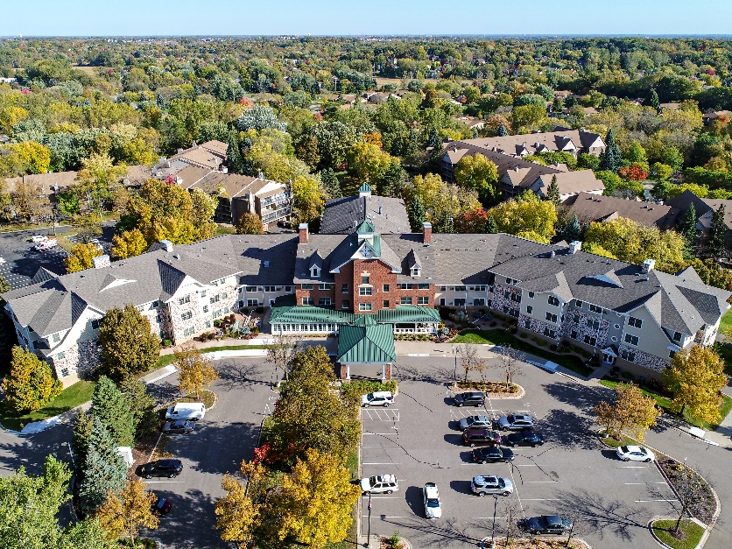

Implementation

The four priorities outlined in the HRA strategic plan and implementation of the action steps will require the HRA to prioritize their time, staff capacity and financial resources to be successful. The following is a schedule to help guide the HRA and staff in the successful planning and implementation of the HRA Strategic Plan action steps.

Priority | Actions Steps | Timing | Financial Resources | Impact on HRA Mission
1.a | Tenant Protection Ordinance |  | $ | ✪✪
1.b | Local 4d Affordable Housing Incentive |  | $$ | ✪✪✪
1.c | NOAH Rehabilitation and Maintenance Program |  | $$ | ✪✪✪
2.a. | Mixed Income Housing Policy |  | $$ | ✪✪✪
2.b. | Increase Options for Affordable First-Time Buyers |  | $$ | ✪✪
3.a | Identify and Prioritize Areas for Redevelopment |  | $$ | ✪✪
3.b | Assist with Assembly of Land for Redevelopment |  | $$ | ✪✪
3.c. | Educate the Community and Policy Leaders on the Benefits of Investing in Redevelopment |  | $ | ✪✪
4.a | Increase HRA Levy Dollars |  | $$ | ✪✪✪
4.b. | Adopt a Public Subsidy  Policy |  | $ | ✪✪

Timing Key
Short Term | Median Term | Longer Term
Work on Immediately and will have the most substantive impact on achieving the HRA mission. | Policies and programs that require additional research and collaboration | Outside resources, stakeholder input and collaboration required to fully understand the implication of the policy or program
Complete in 2021 | Complete within 1-3 years | Complete within 3-5 years

Financial Resources Key
Low Cost | Medium Cost | High Cost
$ | $$ | $$$
Ability to complete with existing resources | A modest increase in the HRA levy and budget would be required | A substantial increase in the HRA Levy and budget would be required

Impact in Achieving HRA Mission
Low Impact | Medium Impact | High Impact
✪ | ✪✪ | ✪✪✪
Limited number of residents benefit and little to no property value increase from implementation of program or policy | Several residents benefit and/or increased property value results from implementation of program or policy | Many residents benefit and/or larger property value increase resulting from implementation of program or policy

